5.4 Summary of Conic Sections

If a plane passes through a double right circular cone there are four possible resulting curves. These curves are the parabola, circle, ellipse, and hyperbola. These curves are called conic sections and are shown below.
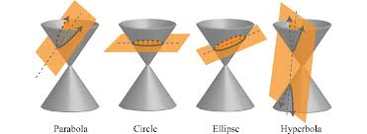

The Equation of a Parabola: (opening up or down)
The parabola
has focus
and directrix where and is the vertex.

The Equation of a Parabola: (opening left or right)
The parabola
has focus
and directrix where and is the vertex.
Note: If then the parabola opens to the right. If then the parabola opens to the left..
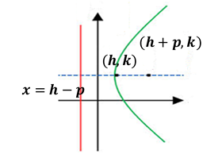
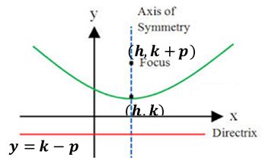

The Equation of an Ellipse: (with a horizontal major axis and center at the origin)
The ellipse with center at the origin and equation

has vertices , endpoints of the minor axis , and foci .
where

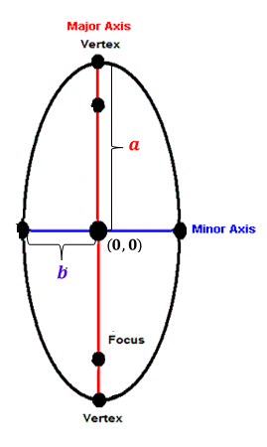
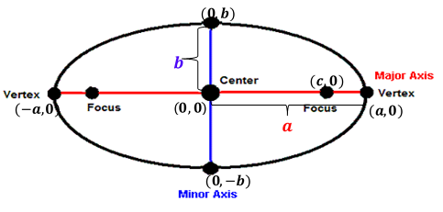
The Equation of an Ellipse: (with a vertical major axis and center at the origin)
The ellipse with center at the origin and equation

has vertices , endpoints of the minor axis , and foci .
where

Equation for a Circle
The standard equation of a circle with center and radius r is

Note: By dividing both sides of this equation by we obtain . So clearly a circle is an ellipse with major and minor axes of the same length.
The Equation of a Hyperbola: (opening left or right)
The equation of a hyperbola with center at the origin with foci and
x-intercepts is
where

The differences of the distances from any point of the hyperbola to the two foci is 2a.

The Equation of a Hyperbola: (opening up or down)
The equation of a hyperbola with center at the origin with foci and
x-intercepts is
where

The differences of the distances from any point of the hyperbola to the two foci is 2a.

Note: With hyperbolas it is not important whether a or b is the larger value. We always think of a as the value beneath y and b as the value beneath x.

Note: If then the parabola opens up. If then the parabola opens down.

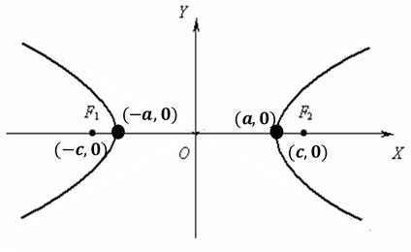
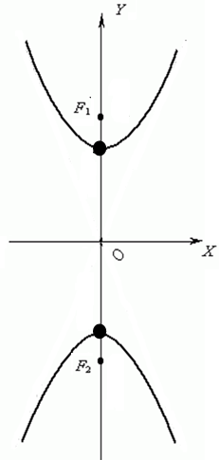

Example 1: Determine what type of conic section represented by the equation and sketch a rough graph of the conic.

We must complete the square in order to get the equation in a form that we can recognize.
From this we recognize that the equation determines a hyperbola which opens vertically and has center .
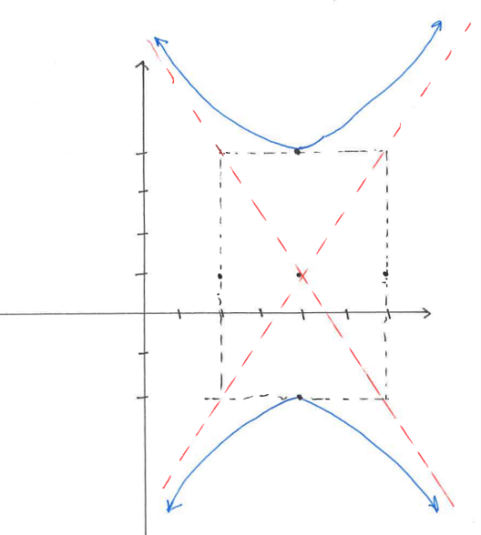

Example 2: Determine what type of conic section represented by the equation and sketch a rough graph of the conic.

The center of the ellipse occurs at the point:
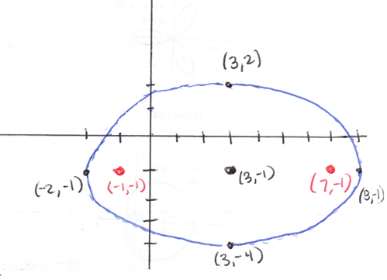

Example 3: Determine what type of conic section represented by the equation and sketch a rough graph of the conic.

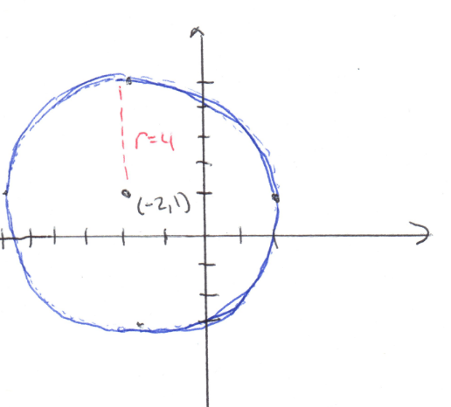

So we have a circle with center and radius .

Example 4: Determine what type of conic section represented by the equation and sketch a rough graph of the conic.

Clearly this is a quadratic that opens right and has vertex .

